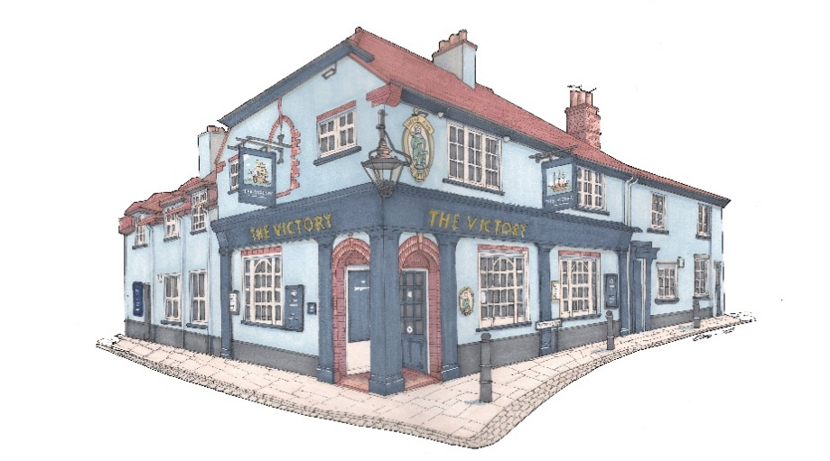

Small plates £10
Chorizo, roast peppers, rouille (GF)
Classic bruschetta, garlic & basil pesto
Parma ham, corn-fed chicken & herb terrine, toast *
Brown shrimp & chilli fishcakes, sweet chilli (GF)
Arancini, dolcelatte & tomato salsa (GF) (V)
Smoked mackerel pate, cornichons, toast *
King prawns, garlic & chilli oil (GF)
Smoked salmon, pickled cabbage, sesame, soy dressing (GF)
New Zealand green lip mussels, coconut, coriander & chilli, toast *
Sweet chilli chicken wings (GF)
Deep fried whitebait, tartare sauce
BBQ ribs (GF)
Paprika smoked chicken goujons, lemon mayo (GF)
Cod goujons, tartare sauce (GF)
Sauté wild mushroom, toast (V)

ANY 3 FOR £25

Signature Dishes
Chargrilled ribeye steak, sauté potatoes, wild mushrooms, tomatoes & garlic butter (GF) £30
Roast fillet of wild sea trout, king prawns, samphire, roasted new pots & seafood velouté (GF) £28
Roast supreme corn-fed chicken, St Auger, fondant potato & wild mushrooms (GF) £28
Mediterranean vegetable paella, saffron & chargrilled asparagus (GF) (V) £19
Please advise your server of any food allergies or intolerances.
* Gluten free option available *

